The Ideal Way to Organize Applied Kinesiology!

WHAT TO DO FIRST, NEXT & LAST!

QUINTESSENTIAL APPLICATIONS

8 Atlanta WORKSHOPS

“Finally, someone has done the near impossible! Imagine the 40+ years of AK organized into a workable… hierarchy of what needs to be done first, second and next. Follow the QA protocol and know what to do for any patient on any visit!” - Scott Walker, DC, Encinitas, CA…N.E.T. Founder

These QA Workshops Complement the

Comprehensive QA Home Study Course Online

Docs go to: https://qahomestudy.com/amodio

Students go to: https://qahomestudy.com/amodio/student

Session & Dates: Topics:

Workshop 1: Oct. 26, 2019 Hands-On Pain Relief / Hip and Low Back (QA Sessions 1 & 2)

Workshop 2: Nov. 23, 2019 Shoulder/ Fatigue & Inflammation (QA Sessions 3 & 4)

Workshop 3: Jan. 25, 2020 Spinal Adjusting / Fatigue & Inflammation (QA Sessions 5 & 6)

Workshop 4: Mar. 7, 2020 Head & Neck / Immune System (QA Sessions 7 & 8)

Workshop 5: Jul. 25, 2020 Lower Limb/Low Endocrine Function/Adrenal Stress/Emotional Stress

Techniques (QA Sessions 9& 10)

In order to achieve a complete educational experience, it is highly recommended that the participant study the respective QA Sessions online prior to attending the QA Workshops.

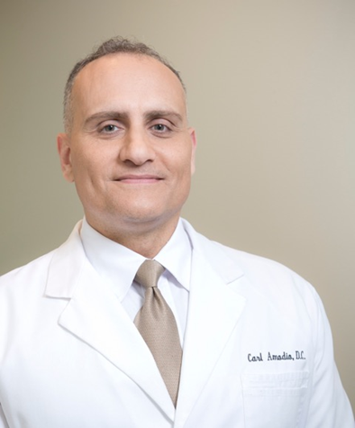
Carl Amodio, D.C., DIBAK received his diplomate with the International Board of Applied Kinesiology in 2011 and has been in practice since 2001. He began incorporating the QA Clinical Protocol in 2005 after attending the inaugural QA seminar series. He is a graduate of Life University (2001) and is the owner of Optimal Health in Roswell, GA. He is also on faculty at Life teaching the elective: Introduction to Applied Kinesiology which he designed and introduced to the school in 2006 at the request of his friend and colleague Dr. William Harris. Dr. Amodio also helped to start the first ever AK club on campus at Life in 2006, which is still going strong today, with much excitement and interest. He is currently the faculty advisor for the club. Dr. Amodio has been a co-lecturer and workshop leader with QA before, and is now very excited to be doing the first ever QA workshop series!

LOCATION & TIMES: (Workshops 1-8)
LOCATION & TIMES:
Life University, CCE 117, Marietta, GA
SATURDAYS: 9:30 to 5:30 PM

SEMINAR FEES (per session):

Doctors: $250 Students: $150

Payments received 30 days prior to the seminar receive $25 off.

CANCELLATION (Transfer) POLICY:
A $25 cancellation fee will be charged for cancellation within 10 days prior to any session.
However, the seminar fee may be transferred to another session at no charge.

WHO IS ELIGIBLE TO ATTEND: THIS COURSE IS OPEN TO DOCTORS LICENSED TO DIAGNOSE AND STUDENTS IN A DEGREE PROGRAM LEADING TO A LICENSE TO DIAGNOSE. THIS IS IN KEEPING WITH THE GUIDELINES OF THE INTERNATIONAL COLLEGE OF APPLIED KINESIOLOGY.

Tables Will Be Provided – But Feel Free to Bring Your Own

REGISTER:

PLEASE PRINT LEGIBLY:

First Name ____________________________ Last Name ___________________________________ Degree ______

Address ________________________________________ City ___________________ State _________ Zip ______

Tel __________________________________ Email ____________________________________________________

VISA/MC/AMEX # ________ - _________ - _________ - _________ EXP ____ / ____ CVV ____ Zip ______

Make Checks Payable & Mail to: Optimal Health
555 Sun Valley Dr. NW, Suite A1
Roswell, GA 30076
(770) 993-4633

PayPal email: drcarl9@gmail.com

In Order to Ensure Optimal Learning, the Number of Participants will be Limited…
REGISTER NOW!

Go to the links above to purchase the QA Online Comprehensive Course

